Part 1:
sudo systemctl stop ssh
sudo systemctl start ssh
sudo systemctl restart ssh
sudo systemctl status ssh
sudo systemctl enable ssh
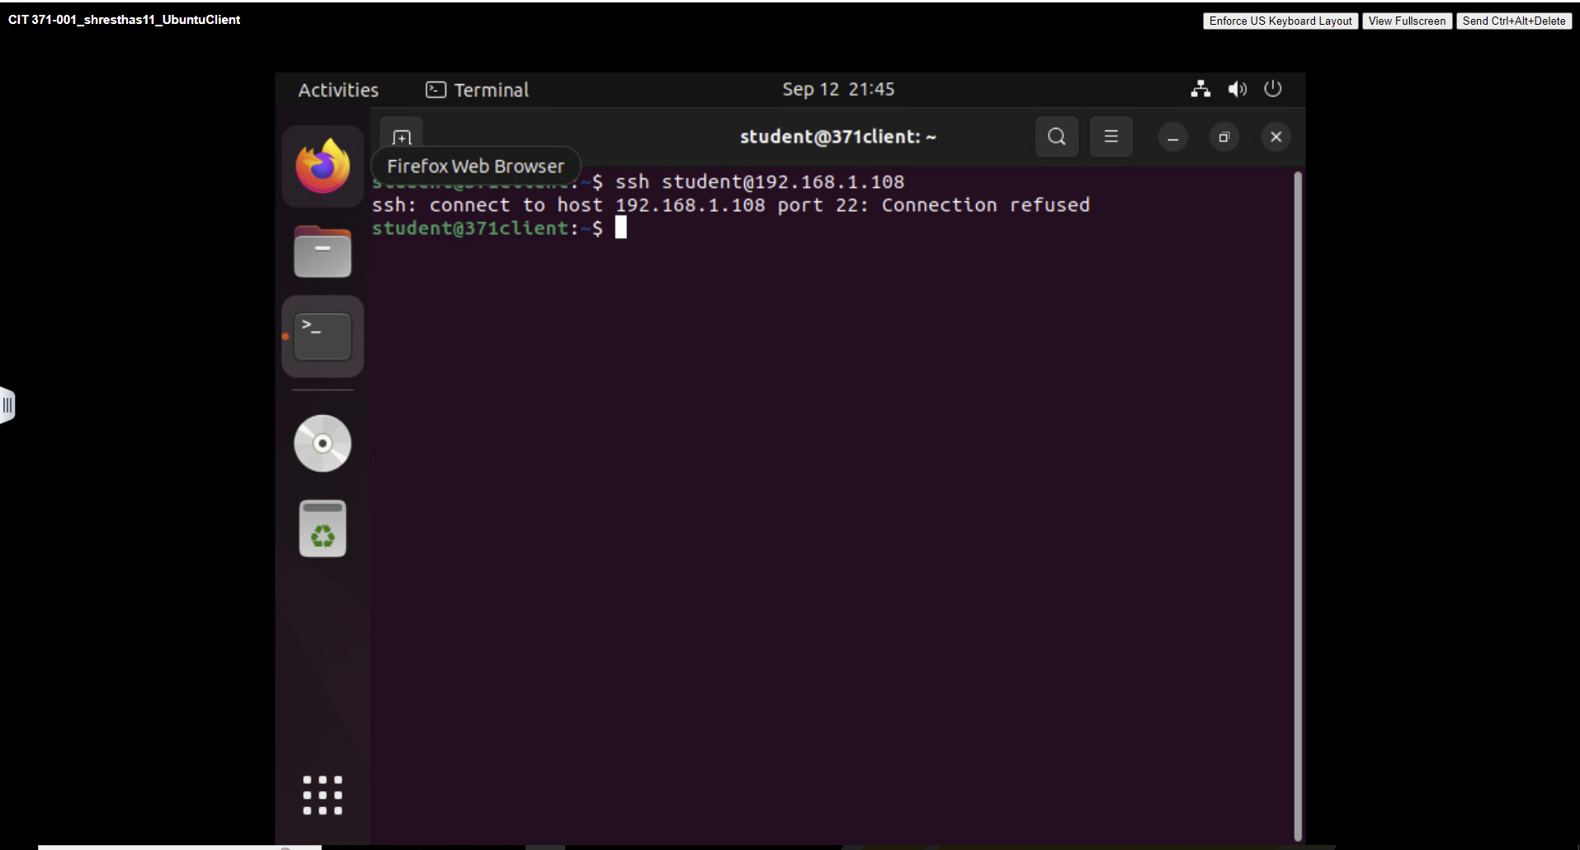

Part 2:
[Unit]
Description=Start Git Daemon

[Service]
ExecStart=/usr/bin/git daemon --reuseaddr --base-path=/srv/git/ /srv/git/
Restart=always
RestartSec=500ms

StandardOutput=syslog
StandardError=syslog
SyslogIdentifier=git-daemon

User=student
Group=student

[Install]
WantedBy=multi-user.target

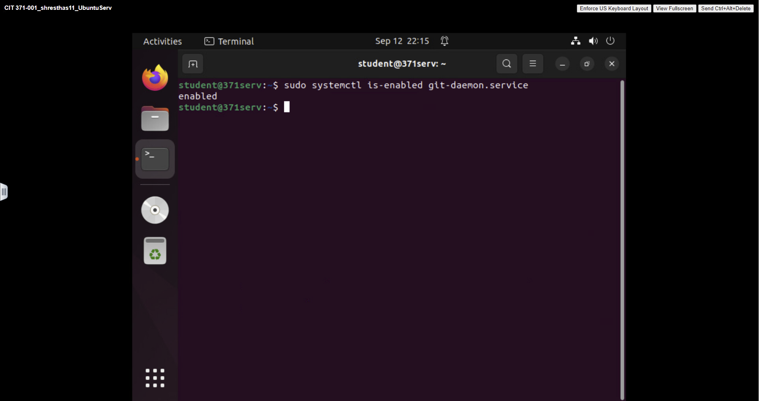

Part 3:
The number of users logged in: 1

The number of sleeping processes: 288

The amount of memory in MiB that is free: 1921

The amount of swap in MiB that is being used: 0

The highest-number pid listed for the student user: 4020
